Superstore Marketing Campaign Analysis

Submitted by: SONU KUMAR
Course: Career 247 — Data Analytics with GenAI
Project Type: Capstone Project
Date: February 2026

Contents
BUSINESS OVERVIEW AND KPIs 3
DATA ACQUISITION AND VALIDATION 4
EDA PART 1 — CUSTOMER DEMOGRAPHICS 5
EDA PART 2 — SPENDING AND CHANNEL ANALYSIS 6
CUSTOMER SEGMENTATION 7
STATISTICAL ANALYSIS 8
MACHINE LEARNING MODEL 9
MACHINE LEARNING MODEL — SMOTE IMPROVEMENT 10
STRATEGIC INSIGHTS — KEY FINDINGS 11
ACTIONABLE RECOMMENDATIONS 12
CONCLUSION 13
TOOLS AND TECHNOLOGIES USED 14

BUSINESS OVERVIEW AND KPIs
The Superstore chain runs a year-end promotional campaign where existing customers are invited to purchase a Gold Membership that offers a 20% discount on all purchases. The goal of this project is to analyze customer data to understand who is likely to accept the membership, which customers spend the most, and how future campaigns can be improved.
Dataset Overview:
The raw dataset contained 2,240 customers and 22 original columns covering demographics, spending behavior, channel usage, and campaign response. After data cleaning and feature engineering in Python, 7 new columns were added — Age, Total Spend, Total Purchases, Tenure, Category Breadth, Web Ratio, and Income Bracket — bringing the final dataset to 29 columns.

Key Performance Indicators (KPIs):
KPI | Value
Total Customers | 2,240
Gold Membership Response Rate | 14.91%
Total Revenue Spent by Customers | $1,356,988
Average Spend per Customer | $605.80
Complaint Rate | Very low
Customer Enrollment Period | Jan 2012 to Dec 2014

What is Response Rate in simple words: Out of 2,240 customers, only 334 said YES to the Gold Membership. 334 divided by 2240 equals 14.91%. This means 85% of customers did NOT accept — there is a lot of room to improve.
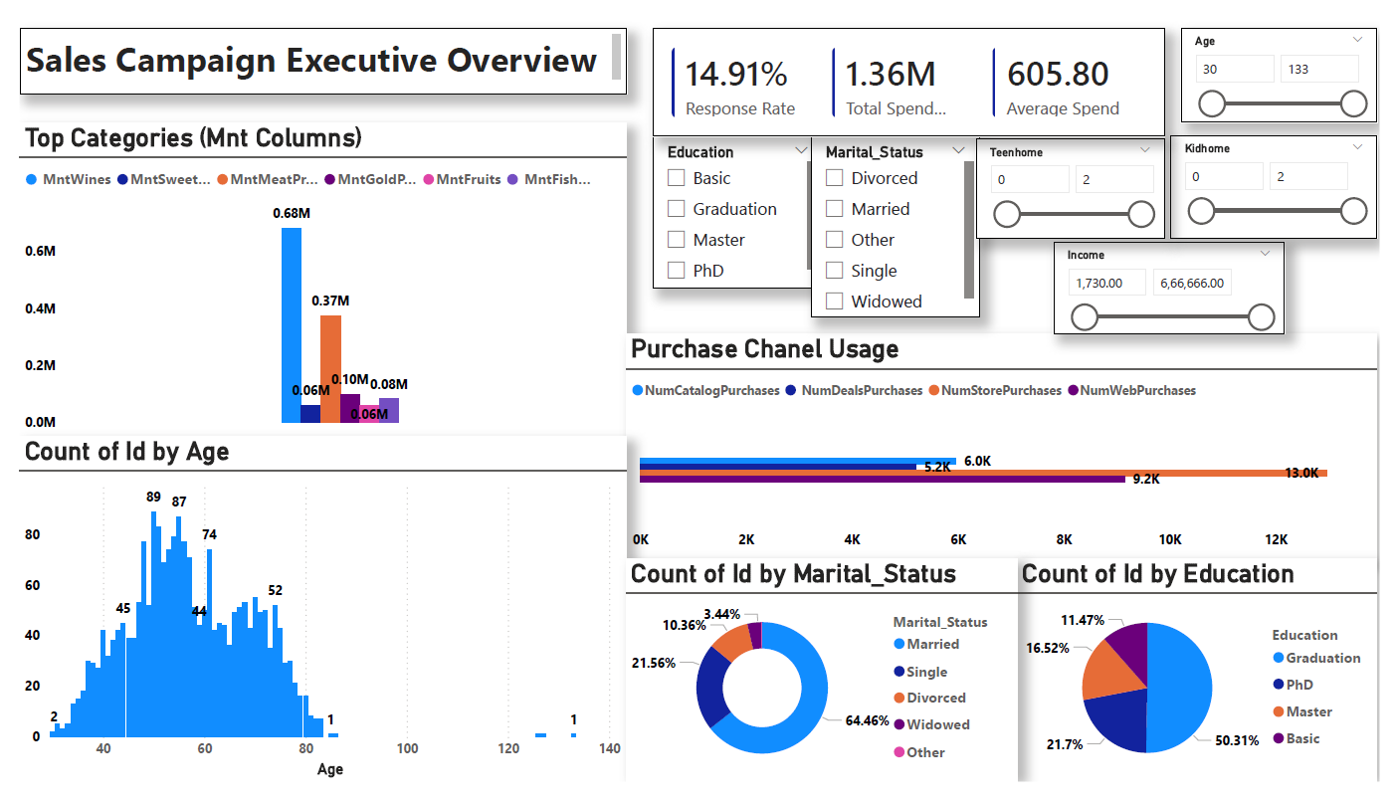
Figure 1: Executive Overview Dashboard showing Response Rate 14.91% and Total Spend

DATA ACQUISITION AND VALIDATION
The data was first imported into Excel for a visual check, then loaded into a MySQL database, and finally connected to Python using SQLAlchemy for advanced analysis.
Validation Results:
Total rows confirmed as 2,240 with no duplicate IDs. The Income column had 24 missing values which were filled using the median income value in Python. No duplicate customer records were found.
Data Anomalies Found:
One customer had a birth year of 1893, making their calculated age 133 years — this is clearly a data entry error. One customer had an income value of 666,666 — this is an extreme outlier far above all other income values. Both anomalies were noted and handled appropriately.
Date Information:
Customers enrolled between 8 January 2012 and 6 December 2014. The gap between the first and last enrollment date is 1,063 days, which means the company gathered its customer base over approximately 3 years.
Feature Engineering Done in Python:
New Column Added | How It Was Created
Age | 2026 minus Year_Birth
Total_Spend | Sum of all 6 Mnt columns
Total_Purchases | Web + Catalog + Store purchases added
Tenure | Days since customer enrolled
Category_Breadth | Count of product categories with non-zero spend
Web_Ratio | Web purchases divided by Total purchases
Income_Bracket | Low, Medium, High groups created from Income

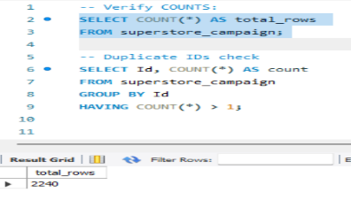
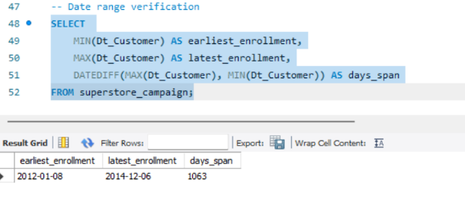
Figure 2:SQL Query confirming 2,240 rows loaded with no duplicates
Figure 3: Enrollment date range — 2012 to 2014, spanning 1,063 days
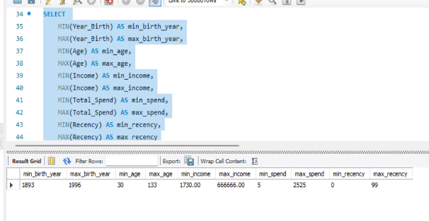
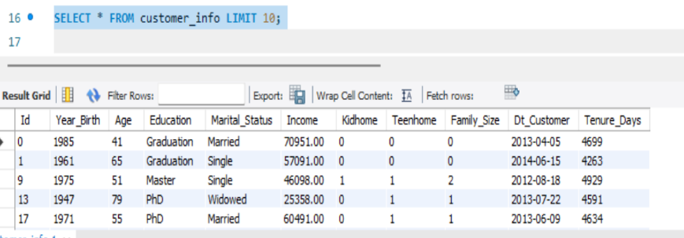

Figure 5: customer_info view showing Age, Tenure, and Family Size fields

Figure 4: Range check showing age outlier of 133 and income outlier of 666,666

EDA PART 1 — CUSTOMER DEMOGRAPHICS
Education Level: The majority of customers, 1,127 out of 2,240, are Graduates making up 50.31% of the base. PhD holders are second at 21.7% with 486 customers. Master's degree holders are 16.52% and Basic education customers are the smallest group at 11.47%.
Marital Status: Married customers dominate at 64.46% with 1,444 customers. Single customers are 21.56% with 483. Divorced customers are 10.36% with 232. Widowed customers are 3.44% with 77. A small group of 4 customers had unusual entries like "Absurd" which were grouped under "Other."
Age Distribution: Customer ages range from 30 to 99 years with one outlier at 133 (data error). The majority of customers are between 40 and 70 years old based on the histogram.

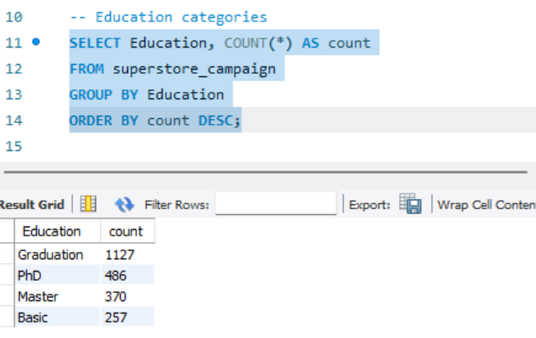
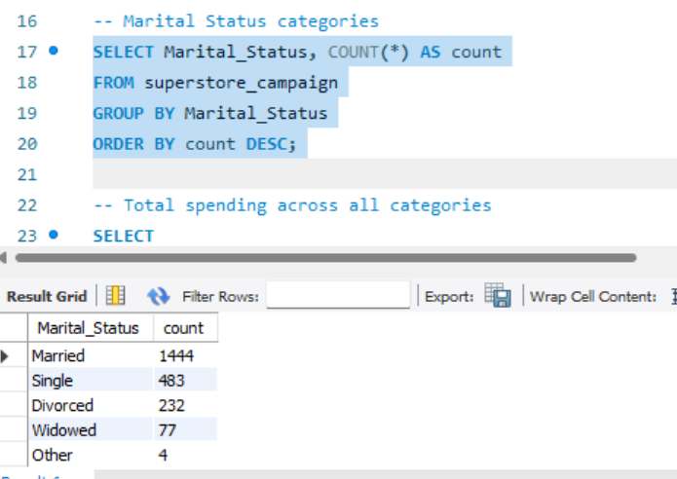

Figure 6: Education category breakdown — Graduation is the largest group
Figure 7: Marital status distribution — Married customers are 64.46% of the base

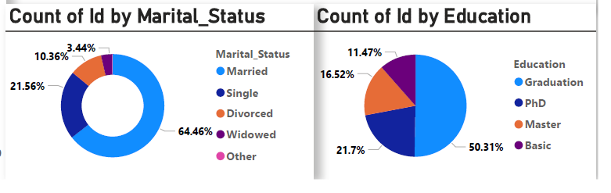
Figure 8: Visual breakdown of Education and Marital Status from Power BI dashboard

EDA PART 2 — SPENDING AND CHANNEL ANALYSIS
Spending by Product Category: Wine is the top revenue category with $680,000 in total customer spending. Meat products are second at $370,000. Gold products generated $100,000. Fruits and Sweets are the lowest performing categories at $60,000 each. Wine and Meat together represent approximately 77% of all customer spending.
Total Spend Distribution: The spending distribution is right-skewed. Most customers spend very little — over 650 customers spend close to zero. A small number of customers spend up to $2,500. This is a classic pattern where a small group of customers drives most revenue.
Income Distribution: The Income Boxplot shows that most customers earn between $30,000 and $90,000. There is one extreme outlier at $666,666 which was flagged as a data error.
Purchase Channel Usage: In-Store shopping is the most popular channel with 13,000 total store purchases. Web purchases total 9,200 and catalog purchases are 6,000. Deals purchases are 5,200.
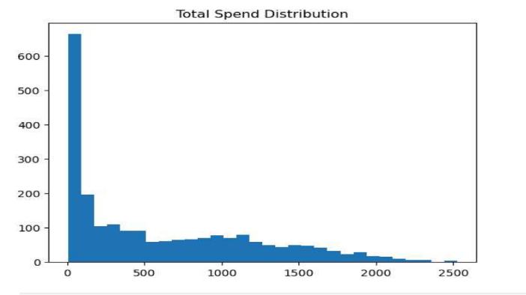
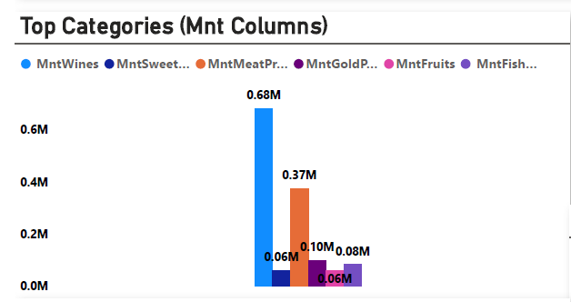
Figure 9: Total spend by product category — Wine leads at $0.68M

Figure 10: Right-skewed total spend distribution — most customers are low spenders
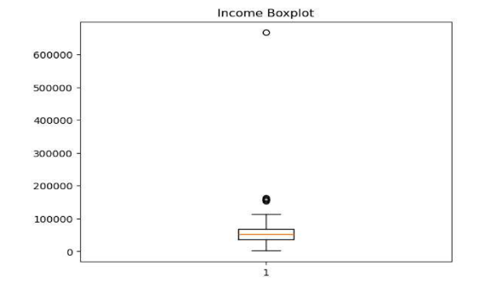
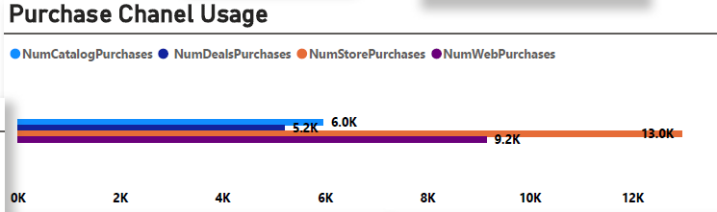

Figure 11: Income distribution with one extreme outlier at 666,666
Figure 12: Purchase channel usage — In-store is dominant

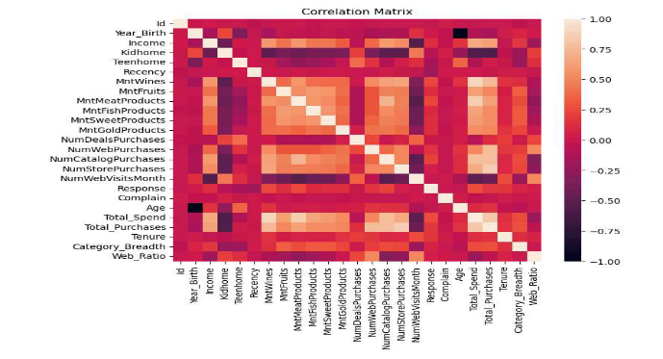

Figure13: Correlation matrix showing Income and Total Spend are strongly linked to Response

CUSTOMER SEGMENTATION
Segmentation by Spending Level:
Segment | Spend Range | Customer Count
Low Spender | Below $500 | 1,245 (55.6%)
Medium Spender | $500 to $1,500 | 749 (33.4%)
High Spender | Above $1,500 | 246 (11%)
The majority of customers are Low Spenders. However the 246 High Spenders are the most valuable group and should receive priority attention.
Segmentation by Shopping Channel:
Segment | Count
In-Store Shopper | 1,563
Digital Shopper | 370
Mixed Shopper | 297
Inactive | 10

Key Finding — Children Reduce Spending: Customers without any children at home spend an average of $1,106. Customers with children spend only $406 on average. This is a 2.7 times difference showing that family obligations significantly reduce discretionary spending.
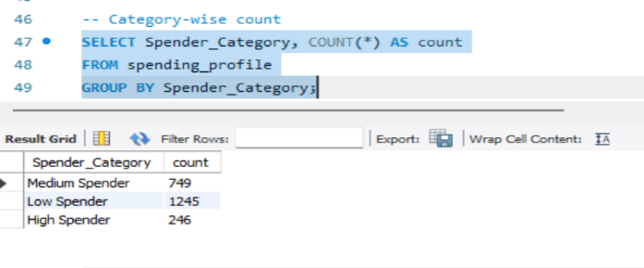
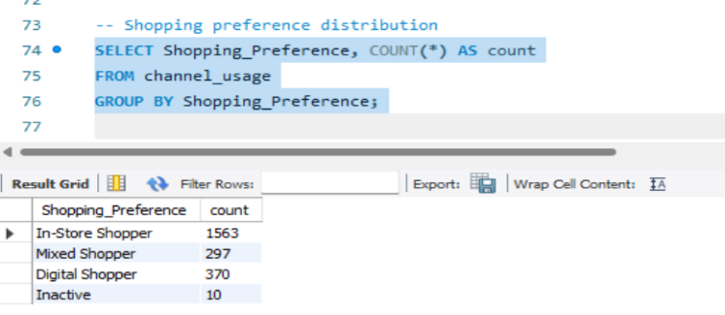

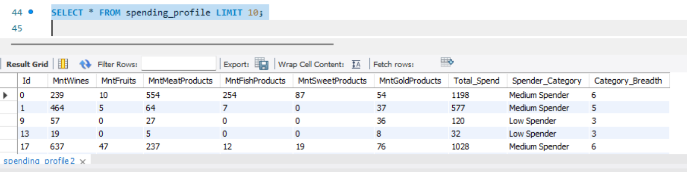
Figure 16: Sample rows from spending_profile view showing category breadth data
Figure 14: Spender category distribution — 1,245 low spenders vs 246 high spenders
Figure 15: Shopping preference — 1,563 in-store shoppers dominate

STATISTICAL ANALYSIS
Three types of statistical tests were performed to validate findings with mathematical evidence.
Test 1 — T-Test: Do children at home affect spending and membership acceptance?
A T-Test compares the average values of two groups to see if the difference is real or just by chance.
Result: Customers with children spend $406 on average versus $1,106 for customers without children. The p-value is almost zero (2.02e-158) which means this difference is 100% statistically significant and not by chance. Similarly, the membership acceptance rate for customers with children is only 10.3% versus 26.5% for those without children (p-value = 1.04e-22).
Test 2 — ANOVA: Does education level affect total spending?
ANOVA tests whether differences across multiple groups are significant.
Result: Basic education customers spend $409, Graduation customers spend $620, Master's customers spend $612, and PhD customers spend $672. The p-value of 0.00000018 confirms that education level has a significant effect on spending.
Test 3 — Chi-Square: Is education level linked to membership acceptance?
Chi-Square tests whether two categorical variables are related.
Result: The p-value of 0.000088 confirms that education level is significantly related to whether a customer accepts the Gold Membership. PhD holders accept at 20.78% rate while Basic education customers accept at only 9.34%.

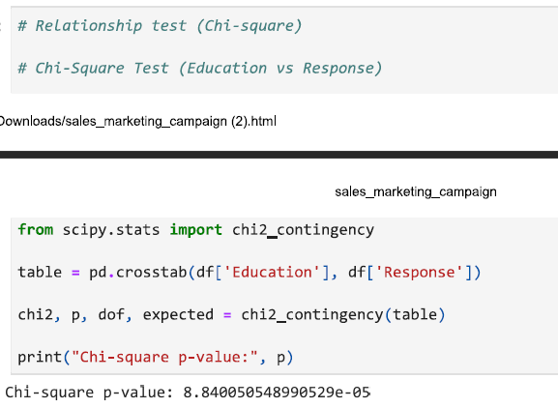
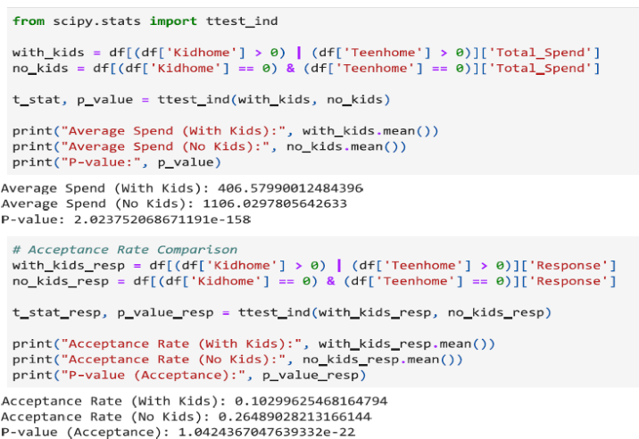

Figure 18: Chi-square test confirming education and response are significantly related
Figure17: T-test results comparing spend and acceptance rate for families vs non-families

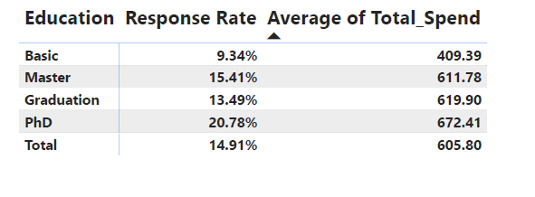

Figure19: Response rate and average spend by education level from Power BI

MACHINE LEARNING MODEL
A Random Forest Classification model was built to predict which customers will accept the Gold Membership offer. Random Forest works by building many decision trees and combining their results for a more accurate prediction.
Model Setup:
- Target variable: Response column (1 = accepted membership, 0 = rejected)
- Features used: Income, Age, Total Spend, NumWebPurchases, Recency
- Training data: 70% of customers (1,568 customers)
- Testing data: 30% of customers (672 customers)
Model Performance:
Metric | Value
Overall Accuracy | 85.86%
Precision for Non-Acceptors | 88%
Recall for Non-Acceptors | 96%
Precision for Acceptors | 52%
Recall for Acceptors | 26%

The model is very good at identifying customers who will NOT accept (96% recall). However it struggles to identify all customers who WILL accept (only 26% recall). This is because the dataset is imbalanced — only 14.91% accepted, so the model sees far fewer examples of acceptors during training. This can be improved in future by using techniques like SMOTE or class weighting.
Top Features Driving Membership Acceptance:
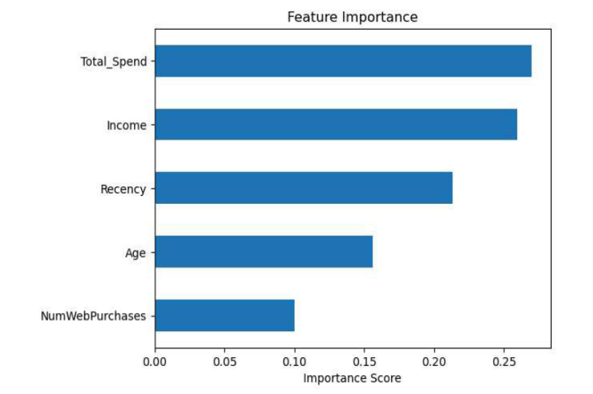
Total Spend is the number one predictor — customers who already spend a lot are most likely to accept. Income is second. Recency is third — recent purchasers are more likely to accept. Age and NumWebPurchases also contribute.
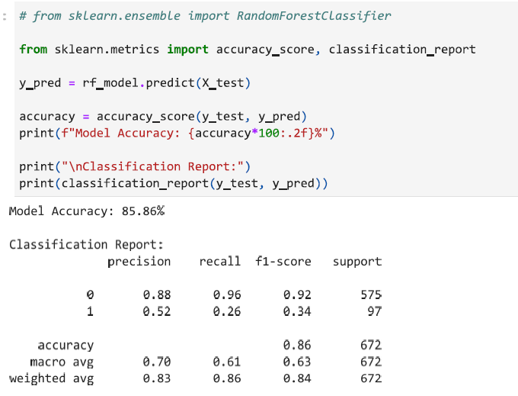

Figure 20: Random Forest model accuracy 85.86% with full classification report
Figure21: Feature Importance chart — Total Spend and Income are the top predictors

MACHINE LEARNING MODEL — SMOTE IMPROVEMENT
The original model had 85.86% accuracy but dataset was imbalanced (85% vs 15%). Due to this, model was only finding 26 actual buyers out of 100.
Table 1 — Model Comparison:
Model | Accuracy | Buyers Found
Original | 85.86% | 26/100
Class Weight | 85.86% | 23/100
SMOTE | 77% | 44/100

SMOTE was applied on training data only. It created synthetic samples for minority class — balancing from 237 acceptors to 1,331.
Table 2 — Before vs After:
 | Before SMOTE | After SMOTE
Class 0 | 1,331 | 1,331
Class 1 | 237 | 1,331

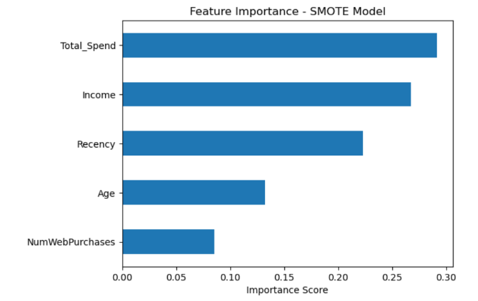
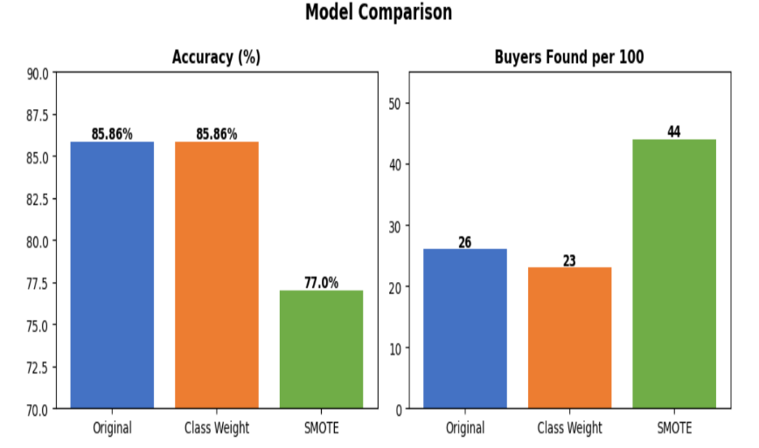
For a limited budget marketing campaign, SMOTE is the best model. It finds 44 buyers per 100 instead of 26 — saving cost and improving campaign results.
Figure 22: Model Comparison — SMOTE improves buyer recall from 26% to 44%
Figure 23: Feature Importance — Total Spend remains most important after SMOTE

STRATEGIC INSIGHTS — KEY FINDINGS
This section summarizes the most important patterns discovered across all stages of analysis.
Finding 1 — PhD customers are the best target segment PhD holders have the highest membership acceptance rate of 20.78% and spend $672 on average — the highest of any education group. Basic education customers respond at only 9.34%. This is a statistically confirmed finding (chi-square p-value = 0.000088).
Finding 2 — Families with children are the most resistant segment Customers with children at home have only 10.3% acceptance rate versus 26.5% for those without children. Their spending is also 2.7 times lower. The Gold Membership in its current form does not appeal to this group.
Finding 3 — In-store shoppers are the largest but least digitally engaged group 1,563 customers prefer physical stores. Only 370 are digital shoppers. Yet digital behavior (NumWebPurchases) is the 5th most important predictor of membership acceptance. Converting some in-store customers to digital could improve campaign results.
Finding 4 — Wine and Meat drive most revenue These two categories together account for approximately 77% of all customer spending. The Gold Membership offer should highlight benefits related to these categories.
Finding 5 — Low Spenders are the majority but give the least return 1,245 customers (55.6%) are Low Spenders. Trying to convert all of them is expensive. Resources should focus on Medium and High Spenders first.
Finding 6 — Recency is critical Customers who purchased recently are significantly more likely to accept the membership. Recency is the 3rd most important predictor in the model. Waiting too long to contact customers after their last purchase reduces conversion chances.
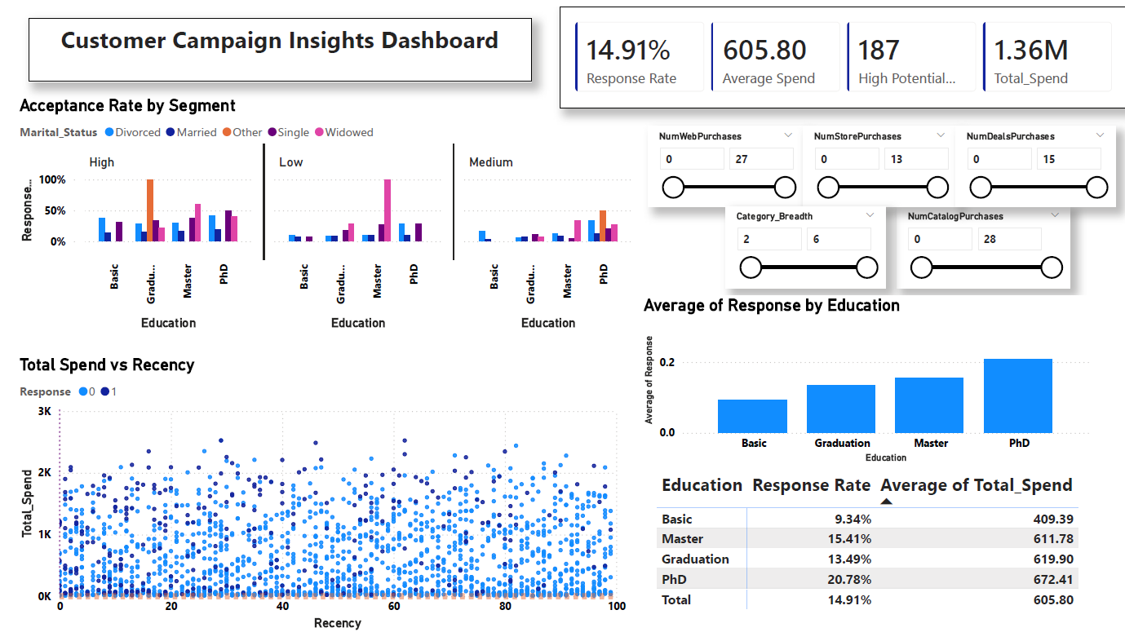

Figure 24: Customer Campaign Insights Dashboard showing acceptance rates and high potential segments

ACTIONABLE RECOMMENDATIONS
Recommendation 1 — Priority Email Campaign for PhD and Master's Degree Customers
Target the 856 PhD and Master's degree customers with a personalized email campaign offering early Gold Membership access. These customers have the highest acceptance rates of 20.78% and 15.41% and the highest average spending. Even a 5% increase in their acceptance rate would add approximately 43 new memberships from this group alone.
Recommendation 2 — Create a Family Gold Bundle
The current Gold Membership has very low appeal for families. Design a Family Gold Pack that includes discounts on food categories like Meat and Fruits which are more relevant to family households. This addresses the 10.3% acceptance rate gap versus 26.5% for non-families.
Recommendation 3 — Win-Back Campaign for High-Recency Customers
Customers who have not purchased recently are less likely to accept the membership. Identify customers with Recency above 60 days and send them a special catalogue offer or a limited-time reactivation discount. Recency is the 3rd most important predictor in the model so addressing it has a direct impact on response rates.
Recommendation 4 — Digital Conversion Initiative for In-Store Shoppers
Offer in-store customers a bonus incentive to try the website — for example a 10% first online purchase discount. This builds digital behavior which is linked to higher membership acceptance rates. The 1,563 in-store shoppers represent a large untapped opportunity.
Recommendation 5 — Wine and Meat Membership Bundle
Design the Gold Membership value proposition around Wine and Meat since these are the categories customers already love. Position the membership as a "Wine and Gourmet Food Club" rather than a generic discount card. This creates stronger emotional connection to the offer.
Recommendation 6 — VIP Outreach for High Spenders
The 246 High Spenders (11% of base) are the most likely to accept the membership based on the model. Give them VIP treatment — personal phone calls, exclusive preview access, or additional benefits like free delivery. Total Spend is the number one predictor of acceptance, so this group should always be the first priority.

CONCLUSION

This project analyzed 2,240 Superstore customers across all major data tools — Excel for validation, MySQL for database management, Python for analysis and machine learning, and Power BI for dashboarding. The overall Gold Membership acceptance rate of 14.91% indicates that while the campaign reaches a large audience, it is only converting a small portion of customers.
The Random Forest model achieved 85.86% accuracy and confirmed that Total Spend, Income, and Recency are the three most powerful predictors of membership acceptance. Statistical tests confirmed that education level and presence of children at home significantly affect both spending and acceptance behavior.
By targeting PhD-educated customers, creating family-friendly membership tiers, re-engaging recently inactive customers, and building digital shopping habits, the Superstore can meaningfully increase its Gold Membership uptake and maximize the return on its marketing investment.
To further improve campaign targeting, three machine learning models were tested to address the imbalanced dataset. The original Random Forest model could only identify 26 buyers per 100 customers. Class weight balancing did not help — recall dropped to 23. After applying SMOTE, buyer identification improved to 44 per 100 customers. Total Spend remained the most important factor across all three models, confirming it is a reliable predictor. SMOTE is recommended for future campaigns as it finds more real buyers without increasing budget.

TOOLS AND TECHNOLOGIES USED
Tool | Purpose
Microsoft Excel | Data validation, conditional formatting, anomaly detection
MySQL Workbench | Database creation, DDL scripts, views, sanity queries
Python (Jupyter Notebook) | Data cleaning, EDA, feature engineering, statistical tests, ML model
Power BI | Executive dashboard and Campaign insights dashboard
Pandas and NumPy | Data manipulation
Matplotlib and Seaborn | Charts and visualizations
Scikit-learn | Random Forest model, train-test split, classification report
SQLAlchemy | Python to MySQL database connection

